

**MAJLIS AMANAH RAKYAT**

**KPM BERANANG**

**TEST 1**

**3/2022 SESSION**

|  |  |  |
| --- | --- | --- |
| **COURSE** | **:** | **WEBSITE APPLICATION DEVELOPMENT** |
| **COURSE CODE** | **:** | **CSC 2713** |
| **DATE** | **:** | **DECEMBER 2022** |
| **DURATION** | **:** | **1 HOUR AND 30 MINUTES** |

**CLO 1 – EXPLAIN THE CONCEPT OF A DYNAMIC WEBSITE IN THE DEVELOPMENT OF A WEBSITE APPLICATION.**

|  |  |
| --- | --- |
| STUDENT NAME: |  |
| STUDENT ID: |  |
| CLASS: |  |

**DO NOT OPEN THIS QUESTION BOOKLET UNTIL YOU ARE TOLD TO DO SO**

***Instruction:***

1. This question paper consists of **THREE (3)** sections.
   1. a. Answer ALL questions in **SECTION A** AND **SECTION B** using **OMR sheet** provided.
   2. b. Answer ALL questions in **SECTION C** in this **question booklet**.
2. Marks may be lost due to the lack of neatness.

*This question booklet consists of 9 printed pages including cover page.*

**©2022 Copyright KPMB, MARA [**Next page

**SULIT**

**SECTION A (15 Marks)**

**Multiple Choice Questions**

Answer all questions. Shade your answer in the OMR provided.

1. A piece of icon or image on a web page associated with another webpage is called ______.
   1. url
   2. plugin
   3. hyperlink
   4. extension
2. Which of followings is not used to generate dynamic web pages?
   1. CSS
   2. JSP
   3. PHP
   4. ASP.NET
3. A ______ requests web pages from the server?
   1. host
   2. client
   3. router
   4. server
4. A ______ web page contains controls with which the user can interact.
   1. static
   2. client
   3. server
   4. dynamic
5. In the client-server architecture, the component that processes the request and sends the response is ______ .
   1. client
   2. server
   3. network
   4. protocol
6. When a user views a page containing a JavaScript program, which machine actually executes the script?
   1. Web server
   2. API controller
   3. Database server
   4. Client machine
7. Django is written using which language?
   1. PHP
   2. Java
   3. Perl
   4. Python
8. Server-side scripting websites consists of two main parts, one is scripting language and other is ______?
   1. Scripting engine
   2. Database engine
   3. User interaction mode
   4. Server interaction mode
9. The server side scripts is _______?
   1. Defined to user
   2. Visible to user
   3. Invisible to user
   4. Managed by the user
10. Connecting websites to backend servers, processing the data and controlling the behavior of higher layers, all these things are done by ______ .
    1. CSS scripts
    2. HTML language
    3. Java Scripts file
    4. PHP Scripting language
11. Which is an advantage of server-side scripting?
    1. Access to client-side data.
    2. No CSS compatibility issue.
    3. Increased load on the client.
    4. No browser compatibility issue.
12. The three parts that constitute backend development are ________ .
    1. Server, database, Java
    2. Server, application, database
    3. Database, mySQL, application
    4. Web design, server, application
13. Which of the following is called as protocol in the URL?
    1. www
    2. http
    3. .com
    4. C4learn
14. The ______ method when used in the method field, leaves entity body empty.
    1. GET
    2. PUT
    3. POST
    4. SEND
15. What does {{name}} mean in Django templates?
    1. {{name}} will be the output.
    2. User can insert their name in HTML.
    3. It will be displayed as name in HTML.
    4. The name will be replaced with values of Python variable.

**SECTION B (10 Marks)**

**True / False Questions**

**[A = TRUE , B = FALSE]**

Answer all questions. Shade your answer in the OMR provided.

1. Dynamic web page generates on demand by a program or a request from browser.
   1. TRUE
   2. FALSE
2. Computer that requests the resources or data from other computer is called as client computer.
   1. TRUE
   2. FALSE
3. A social networking site is the simplest form of website, in which the site’s content is delivered without the use of server-side processing.
   1. TRUE
   2. FALSE
4. A web server is a special software that knows how to not to respond to requests for web pages. (reponds codes such as 404, 200, 403, 201, 204, 500)
   1. TRUE
   2. FALSE
5. Dynamic web pages are written in languages such as: CGI, AJAX, ASP, ASP.NET.
   1. TRUE
   2. FALSE
6. Server-side scripts are interpreted and converted to JavaScript for display on the client’s browser.
   1. TRUE
   2. FALSE
7. GET parameters always start with a question mark (?).
   1. TRUE
   2. FALSE
8. Create, Read, Update, Delete (CRUD) is data-oriented and the standardized use of HTTP action verbs.
   1. TRUE
   2. FALSE
9. Django was designed to help developers take applications from concept to completion as quickly as possible
   1. TRUE
   2. FALSE
10. On the backend, all of the services must be installed on a single computer.
    1. TRUE
    2. FALSE

**SECTION C (25 Marks)**

**Short Answers Questions**

Answer all questions in this question booklet.

1. Differentiate between static and dynamic webpage. (4 marks)
2. Describe web framework and give one example of framework for any server-side scripting language. (3 marks)

[*https://www.example.com/index.html?name1=value1&name2=value2*](https://www.example.com/index.html?name1=value1&name2=value2)

Figure 1

1. Based on the Figure 1 above, answer the questions below:
2. What are the parameters in this URL? (1 mark)
3. Which parameter save the value of the inserted data. (1 mark)

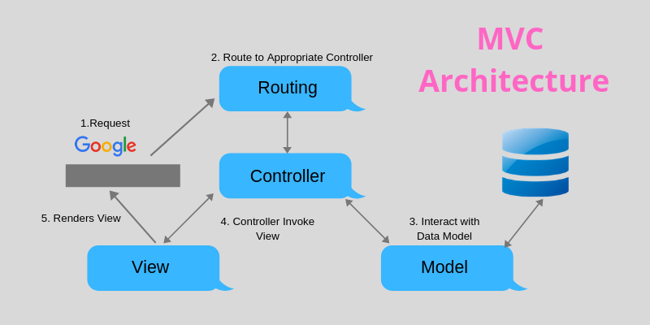

**(i)**

**(iii)**

**(ii)**

Invoke view

Process request to appropriate server

Figure 2

1. Based on the Figure 2 above, complete the diagram:
2. _____________________ (1 mark)
3. ______________________ (1 mark)
4. ______________________ (2 marks)
5. Describe the role of Object Relational Mapping (ORM) in server-side development.

(2 marks)

1. Give two (2) advantages of server-side scripting (4 marks)
2. Complete the table below for operations and methods that can be done when communicating with the database server. (6 marks)

|  |  |  |  |  |
| --- | --- | --- | --- | --- |
| Operation | Method | url (routing) | description | Need body or not? |
| (i) | POST | /student | (v) | (vi) |
| READ | (ii) | /student | Get data for all student | No |
| UPDATE | (iii) | (vii) | Update data for student id=bcs2111001 | Yes |
| (iv) | DELETE | (viii) | Delete data for student id=bcs2111001 | No |

Answer:

1. _________________ (0.5 mark)
2. _________________ (0.5 mark)
3. _________________ (0.5 mark)
4. _________________ (0.5 mark)
5. _________________ (1 mark)
6. _________________ (1 mark)
7. _________________ (1 mark)
8. _________________ (1 mark)

**END OF QUESTION PAPER**